

Partner: Hrvatsko muzikološko društvo/
Croatian Musicological Society

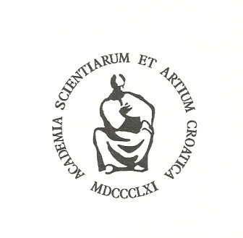

Dept. for the History of Croatian Music, Croatian Academy of Sciences and Arts
Opatička 18, Zagreb, Croatia

International meeting announcement:
Music Migration in the Early Modern Age: People, Markets, Patterns, Styles
Zagreb, 13-14 October 2014.

Impulses for the migration of musicians (composers, performers, teachers, instrument builders/makers, etc.) during the 17th and 18th centuries were often economic in nature, either positive – searching for a new/better place to work – or negative – poor conditions in staying in one place – and supply and demand often regulated their (voluntary) circulations. The market was usually reduced to a few fields: the Church, the town, the nobility, or the theatre, and they were often interwoven (for example, the Church or court musician found extra money as a private teacher, and also as performer in a theatre orchestra). The migrants were the soloist virtuosi, as well as their benefactors/maecenas.
How did they present themselves to the new environment/audience? What type of contracts did they sign? Were they invited, or did they impose themselves? Did they simply migrate for schooling, and then return? Where were they educated? Did they bring music material with them (scores, books, tutorials/manuals)? Did they adopt and implement/disseminate new musical forms, new patterns of music-making, and new styles? Did they follow the original models or modify them? How did their audiences react? Did their guest performances influence the creation of new frames/spaces of music-making? Did they leave notes on their sojourns in foreign countries and how did they assess them? How did they travel? How does the musicologist approach these questions? And researchers from sister disciplines? What methodologies and sources do they use?
The answers to these and many other questions will be sought after within this meeting.
Official language: English

